Build Out U10:
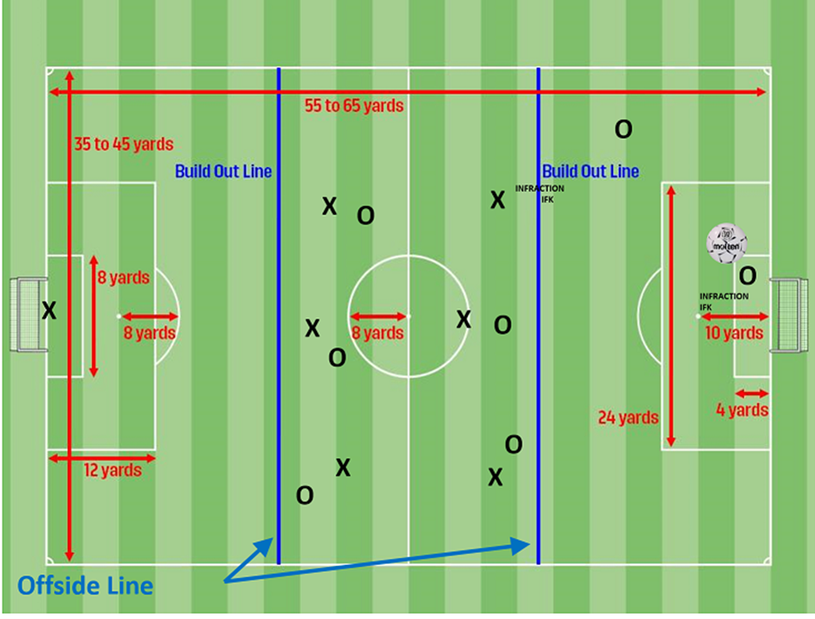
- The spirit of this rule is to encourage the U9 and U10 teams to learn how to play the ball forward from the first third. Traditionally keepers have been able to just punt the ball across the midway line which was a detriment to the players learning how to progress the ball forward from defense to mid field to the attackers.
- When the goalkeeper (Team O) has the ball in his/her hands during play, the opposing team (Team X) must move behind the build-out line until the ball is released from the goalkeeper's possession and crosses the penalty area.
- Once the opposing team is behind the build-out line, the goalkeeper can release the ball by passing (NOT dribbling), throwing, or rolling the ball to a teammate who is on his/her side of the build-out line or beyond the build-out line.
- Section 1R has clarified that the goalkeeper may roll (not bounce) the ball and then pass the ball to a teammate on their side of the build out line.
- PUNTS and DROP KICKS are not allowed from the keeper.
- After the ball is released from the goalkeeper's possession and crosses the penalty area, the opposing team may cross the build-out line and play resumes as normal.
- The goalkeeper releasing the ball from possession or the player taking the goal kick does not have to wait for the opposing players to move behind the build-out line.
- The play from the goalkeeper or from the goal kick can be played to a teammate beyond the build-out line.
- 2022 FALL Season UPDATE - on Goal Kicks, the ball must be kicked and cross the penalty area before the opposing team can cross the build out line to attack the ball.
Offsides:
- The build-out line shall be used as the line to determine offside. Players cannot be penalized for an offside offense between the halfway line and the build-out line.
- Players can be penalized for an offside offense between the build-out line and goal line.
- ARs should position themselves with the build-out line, the second to last defender, or the ball, whichever is closest to the goal.
Guidance to Referees:
- Encourage the opponents to move quickly beyond the build-out line. Do not start the “6-sec clock” until all opponents have retreated behind the build-out line.
- The referee should position themselves on or very close to the build-out line and ask the players to stay behind until the ball is released.
- If a player insists on crossing over the line a couple of times without respecting the referee’s direction; you have an IFK for the goalkeeper’s team… location: on the build-out line, place closest to where the player crossed the line.

